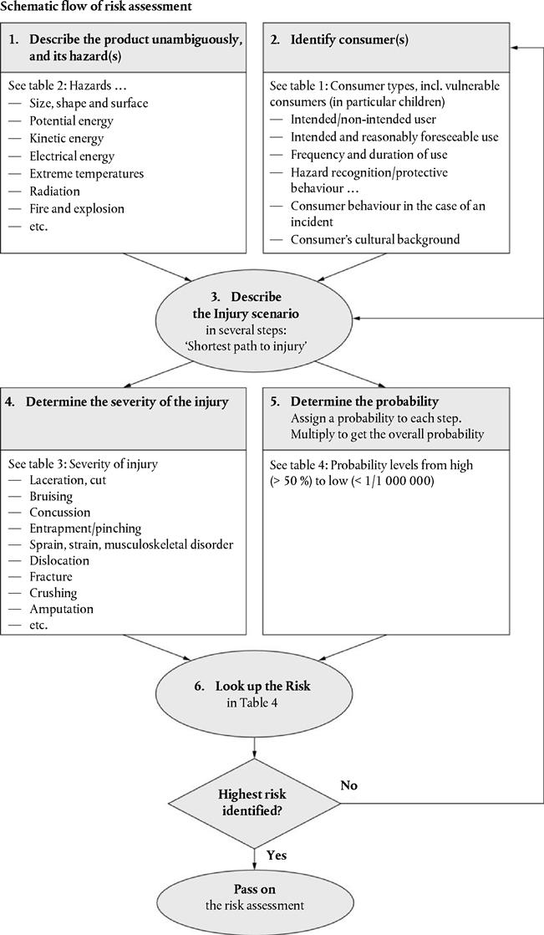

DETERMINATION OF RISKS

Injury Scenario | Injury Type  Injury Location | Severity of Injury  1 - Low  2 - Medium  3 - High  4 - Serious | Probability of Injury | Overall Probability | Risk  1 - Low  2 - Medium  3 - High  4 - Serious
1.

2.

3.

4.

5.

6.

